**Methods**

All the statistical analysis is done with use of R (v. 4.0.5) programming language. The effect of NPA treatment on the change in diameter with the use mixed models. For mixed models’ estimation function *lmer* from *lme4 (v. 1.1-26)* package was used. Specification of mixed models involves population, observable period and their interaction as a fixed effect, and plant id as a random effect.

The effects of treatment on the number of lateral shoots and reproductive, which represent count data, again mixed model is used. The difference is in the assumption that number of lateral shoots and reproductive shoots follow the Poisson distribution.

Data contains observations of 59 plants which were observed from … up to March 2018. Measures were taken three times: in September 2017, December 2017 and March 2018. After removing observation containing missing values the dataset resulted in overall 152 observations.

**Table (1): Number of observations.**

|  |  |  |  |
| --- | --- | --- | --- |
| Month | N | NA | N - NA |
| September 2017 | 59 | 1 | 58 |
| December 2017 | 59 | 9 | 50 |
| March 2018 | 59 | 15 | 44 |
| Sum | 177 | 25 | 152 |

**Results**

Plants treated with NPA have had a clearly smaller average diameter growth and rather higher deviation by December 2017. However, in March 2018 the NPA treated plants showed an increase in growth pace, resulting in slightly higher average diameter (Figure 1) While population treated with water was demonstrating a rapid increase diameter during the first months and then a lower change in the second stage, those which were treated with NPA were experiencing a steady acceleration of diameter growth (Figure 2).

**Figure (1): Diameter by treatment level and stage**

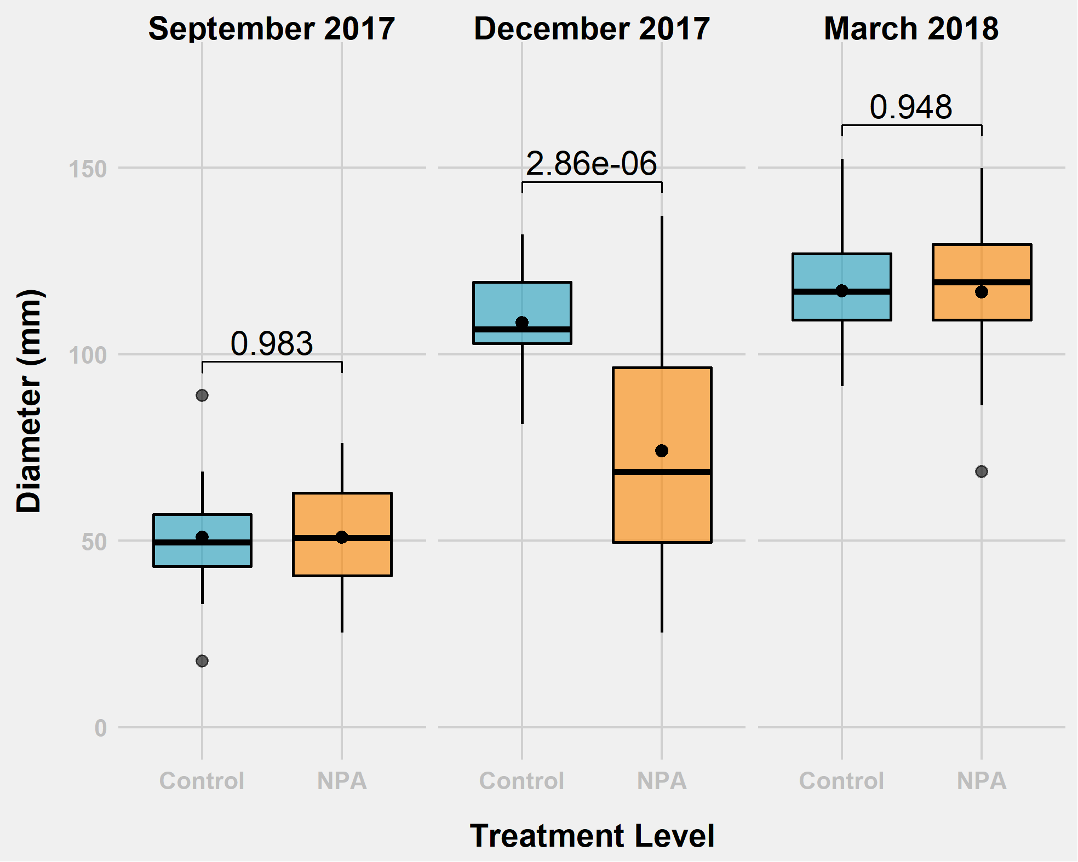

Despite having a different behavior in the process of growth the usage of NPA does not make a significant difference in nominal diameter at the first and the last stages of observation. These ideas are supported with the results of the Student’s T-test (Table 2 and Table 3) and estimates of the mixed effect model for diameter. Coefficients for the stage of experiment are as expected positive, meaning that the plants grow over time. However, coefficients for treatment level are not significant except its interaction with December 2017.

**Figure (2): Diameter change by treatment level and stage**

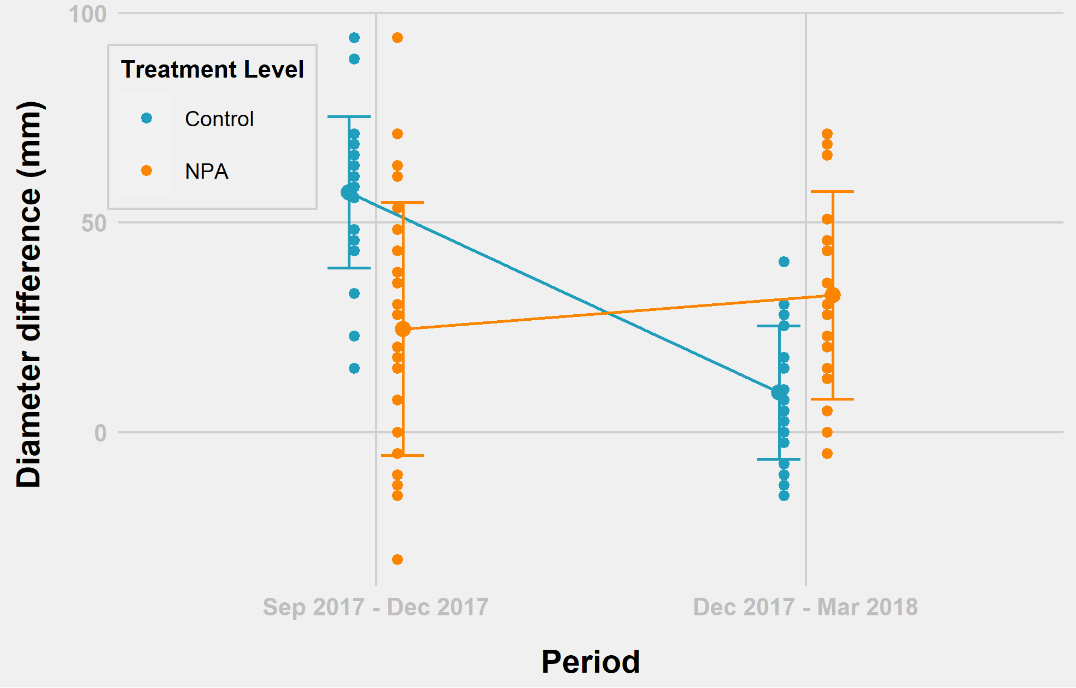

**Table (2)**

$T-tests$**: Diameter ~ Treatment Level**

|  |  |  |  |  |  |
| --- | --- | --- | --- | --- | --- |
| **Stage** | $$H_{0}$$ | $$µ_{Control}$$ | $$µ_{NPA}$$ | $$t$$ | $$p-value$$ |
| September 2017 | $$µ_{Control}-µ_{NPA}=0$$ | **50.89** | **50.97** | **-0.022** | **0.98** |
| December 2017 | $$µ_{Control}-µ_{NPA}=0$$ | **108.45** | **74.13** | **5.485** | **0.00** |
| December 2017 | $$µ_{Control}-µ_{NPA}>0$$ | **108.45** | **74.13** | **5.485** | **0.00** |
| March 2018 | $$µ_{Control}-µ_{NPA}=0$$ | **117.06** | **116.72** | **0.066** | **0.95** |

**Table (3)**

$T-tests$**: Diameter difference ~ Treatment Level**

|  |  |  |  |  |  |
| --- | --- | --- | --- | --- | --- |
| **Stage** | $$H_{0}$$ | $$µ_{Control}$$ | $$µ_{NPA}$$ | $$t$$ | $$p-value$$ |
| September 2017 – December 2017 | $$µ_{Control}-µ_{NPA}=0$$ | **57.20** | **24.62** | **4.643** | **0.00** |
| September 2017 - December 2017 | $$µ_{Control}-µ_{NPA}>0$$ | **57.20** | **24.62** | **4.643** | **0.00** |
| December 2017 – March 2018 | $$µ_{Control}-µ_{NPA}=0$$ | **9.47** | **32.66** | **-3.636** | **0.00** |
| December 2017 – March 2018 | $$µ_{Control}-µ_{NPA}<0$$ | **9.47** | **32.66** | **-3.636** | **0.00** |

**Table (4): Diameter model**

|  |  |  |  |
| --- | --- | --- | --- |
|  | **dia mm** | | |
| *Predictors* | *Estimates* | *CI* | *p* |
| (Intercept) | 50.89 | 44.07 – 57.71 | **<0.001** |
| Treatment Level [NPA] | -0.10 | -9.57 – 9.37 | 0.984 |
| Date [December 2017] | 57.35 | 48.19 – 66.51 | **<0.001** |
| Date [March 2018] | 65.91 | 56.75 – 75.07 | **<0.001** |
| Treatment Level [NPA] * Date [December 2017] | -33.95 | -46.54 – -21.37 | **<0.001** |
| Treatment Level [NPA] * Date [March 2018] | -1.54 | -14.63 – 11.55 | 0.817 |
| **Random Effects** | | | |
| σ2 | 266.16 | | |
| τ00 id | 66.91 | | |
| ICC | 0.20 | | |
| N id | 59 | | |
| Observations | 152 | | |
| Marginal R2 / Conditional R2 | 0.713 / 0.770 | | |

Although treatment level does not seem to contribute to the nominal diameter of plants, it seems to be affecting the growth rate. The growth rate for plants treated with water outpaces growth of the plants under NPA treatment. The mixed effect model (Table 2) for diameter change suggests that watered plants on average grow 57.21 mm comparing with 24,62 mm for plants with NPA. However, when during watering plants seems to lead to only about 9.5 mm growth while using NPA causes a 32.66 mm growth.

**Table (5): Diameter difference model**

|  |  |  |  |
| --- | --- | --- | --- |
|  | **dia diff** | | |
| *Predictors* | *Estimates* | *CI* | *p* |
| (Intercept) | 57.21 | 47.57 – 66.84 | **<0.001** |
| Treatment Level [NPA] | -32.59 | -45.81 – -19.36 | **<0.001** |
| Period [Dec 2017 – Mar 2018] | -47.74 | -61.52 – -33.96 | **<0.001** |
| Treatment Level [NPA] * Period [Dec 2017 – Mar 2018] | 55.78 | 36.44 – 75.11 | **<0.001** |
| **Random Effects** | | | |
| σ2 | 540.34 | | |
| τ00 id | 0.00 | | |
| N id | 50 | | |
| Observations | 92 | | |
| Marginal R2 / Conditional R2 | 0.355 / NA | | |

Table (1): Diameter change model

**Lateral Shoot Rating**

The average amount of lateral shoots seems to be rising for both groups of plants in the with the same intensity. However, plants under the NPA treatment always have prevailing the amount if plants in the group of maximum number of lateral shoots. Thus, in December 2017 they have 4 plants with 3 lateral shoots while plants treated with water do not have any (see Table 6). In March 2018 there were 4 plants with NPA treatment having 4 lateral shoots in comparison with the only representative of control group.

**Figure (3) Lateral shoots by stage**

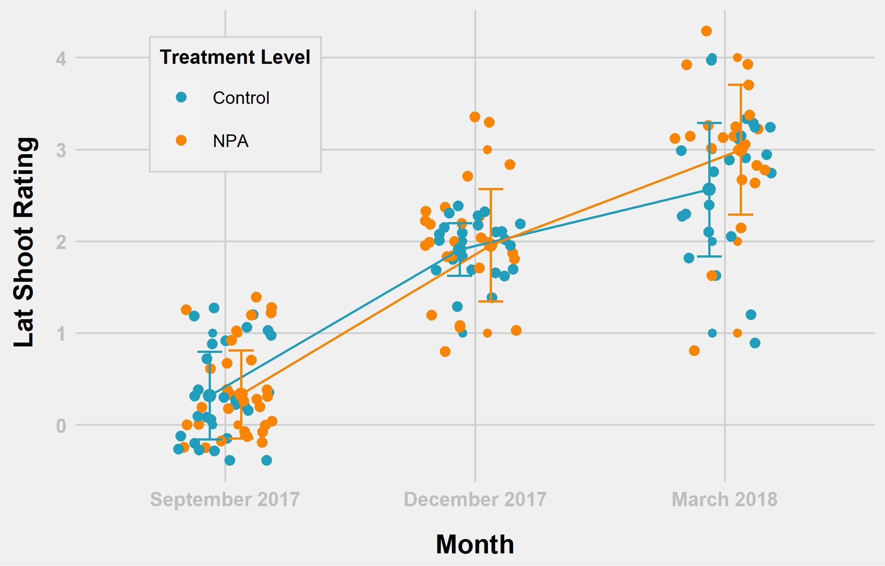

**Table (6): The number of lateral shoots**

|  |  |  |  |  |  |
| --- | --- | --- | --- | --- | --- |
| **Treatment** | **Lateral Shoots** | | | | |
| **0** | **1** | **2** | **3** | **4** |
|  | *September 2017* | | | | |
| **Control** | **19** | **9** | **0** | **0** | **0** |
| **NPA** | **20** | **10** | **0** | **0** | **0** |
|  | *December 2017* | | | | |
| **Control** | **0** | **2** | **21** | **0** | **0** |
| **NPA** | **0** | **5** | **16** | **4** | **0** |
|  | *March 2018* | | | | |
| **Control** | **0** | **2** | **7** | **13** | **1** |
| **NPA** | **0** | **1** | **2** | **14** | **4** |

Still, the difference between two groups is not drastic. Coefficients estimates of the mixed model for the number later shoots represent that only time variable is statistically significant. Oppositely, nor treatment level, nor its interactions with month variables seem to have any influence on the number of lateral shoots.

**Table (7): Diameter difference model**

|  |  |  |  |
| --- | --- | --- | --- |
|  | **lat Shoot Rating** | | |
| *Predictors* | *Incidence Rate Ratios* | *CI* | *p* |
| (Intercept) | 0.32 | 0.17 – 0.62 | **0.001** |
| Treatment Level [NPA] | 1.04 | 0.42 – 2.55 | 0.937 |
| Date [December 2017] | 5.95 | 2.91 – 12.19 | **<0.001** |
| Date [March 2018] | 7.98 | 3.96 – 16.09 | **<0.001** |
| Treatment Level [NPA] * Date [December 2017] | 0.99 | 0.37 – 2.65 | 0.981 |
| Treatment Level [NPA] * Date [March 2018] | 1.13 | 0.43 – 2.97 | 0.808 |
| **Random Effects** | | | |
| σ2 | 0.50 | | |
| τ00 id | 0.00 | | |
| N id | 59 | | |
| Observations | 150 | | |
| Marginal R2 / Conditional R2 | 0.652 / NA | | |

**Inflorescence**

The situation with reproductive shoots is pretty the same as with lateral shootings. The key difference is switching places of the leading group. In September and December, the averages of NPA treated group and Control group are very close to each other, even though there is a unique case of NPA treated plants having 7 reproductive shoots in December. However, the situation changes in March 2018, where the mean clearly differs. The confidence intervals are very wide, though, what does not let us assume the real difference in means to exist.

**Figure (4) Reproductive shoots by stage**

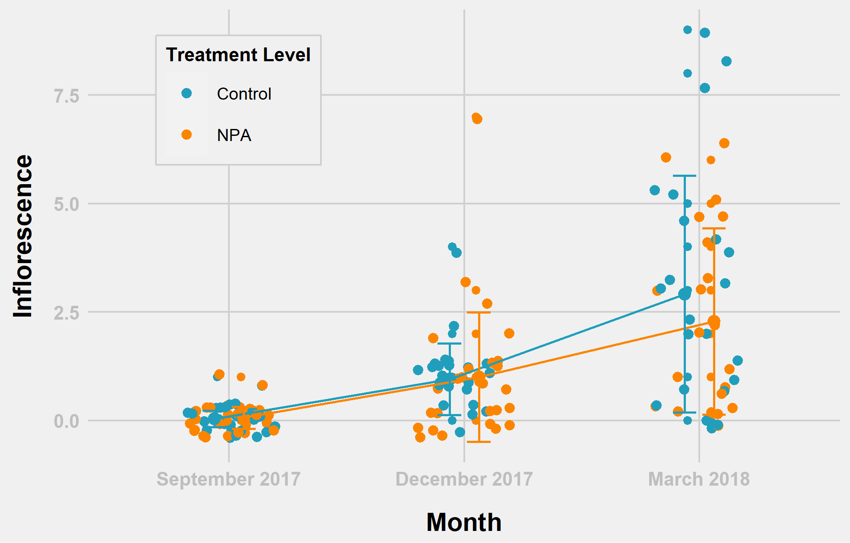

**Table (8): The number of Inflorescence**

|  |  |  |  |  |  |  |  |  |  |  |
| --- | --- | --- | --- | --- | --- | --- | --- | --- | --- | --- |
| **Treatment** | **Lateral Shoots** | | | | | | | | | |
| **0** | **1** | **2** | **3** | **4** | **5** | **6** | **7** | **8** | **9** |
|  | *September 2017* | | | | | | | | | |
| **Control** | **27** | **1** | **0** | **0** | **0** | **0** | **0** | **0** | **0** | **0** |
| **NPA** | **28** | **2** | **0** | **0** | **0** | **0** | **0** | **0** | **0** | **0** |
|  | *December 2017* | | | | | | | | | |
| **Control** | **5** | **16** | **1** | **0** | **1** | **0** | **0** | **0** | **0** | **0** |
| **NPA** | **12** | **10** | **2** | **2** | **0** | **0** | **0** | **1** | **0** | **0** |
|  | *March 2018* | | | | | | | | | |
| **Control** | **5** | **4** | **3** | **3** | **2** | **3** | **0** | **0** | **2** | **1** |
| **NPA** | **6** | **4** | **2** | **3** | **1** | **3** | **2** | **0** | **0** | **0** |

Mixed effects model’s estimates show that the treatment level does not seem to have a statistically significant effect on the number of reproductive shoots.

**Table (9): The number of reproductive shoots**

|  |  |  |  |
| --- | --- | --- | --- |
|  | **inflorescence** | | |
| *Predictors* | *Incidence Rate Ratios* | *CI* | *p* |
| (Intercept) | 0.03 | 0.00 – 0.21 | **<0.001** |
| Treatment Level [NPA] | 1.77 | 0.16 – 20.12 | 0.643 |
| Date [December 2017] | 26.67 | 3.58 – 198.46 | **0.001** |
| Date [March 2018] | 81.24 | 11.24 – 587.11 | **<0.001** |
| Treatment Level [NPA] * Date [December 2017] | 0.58 | 0.05 – 6.84 | 0.664 |
| Treatment Level [NPA] * Date [March 2018] | 0.44 | 0.04 – 5.07 | 0.513 |
| **Random Effects** | | | |
| σ2 | 0.80 | | |
| τ00 id | 0.45 | | |
| ICC | 0.36 | | |
| N id | 59 | | |
| Observations | 152 | | |
| Marginal R2 / Conditional R2 | 0.709 / 0.813 | | |

Appendix 1. Diameter (mm) – Treatment Level

Figure(). QQ-plot

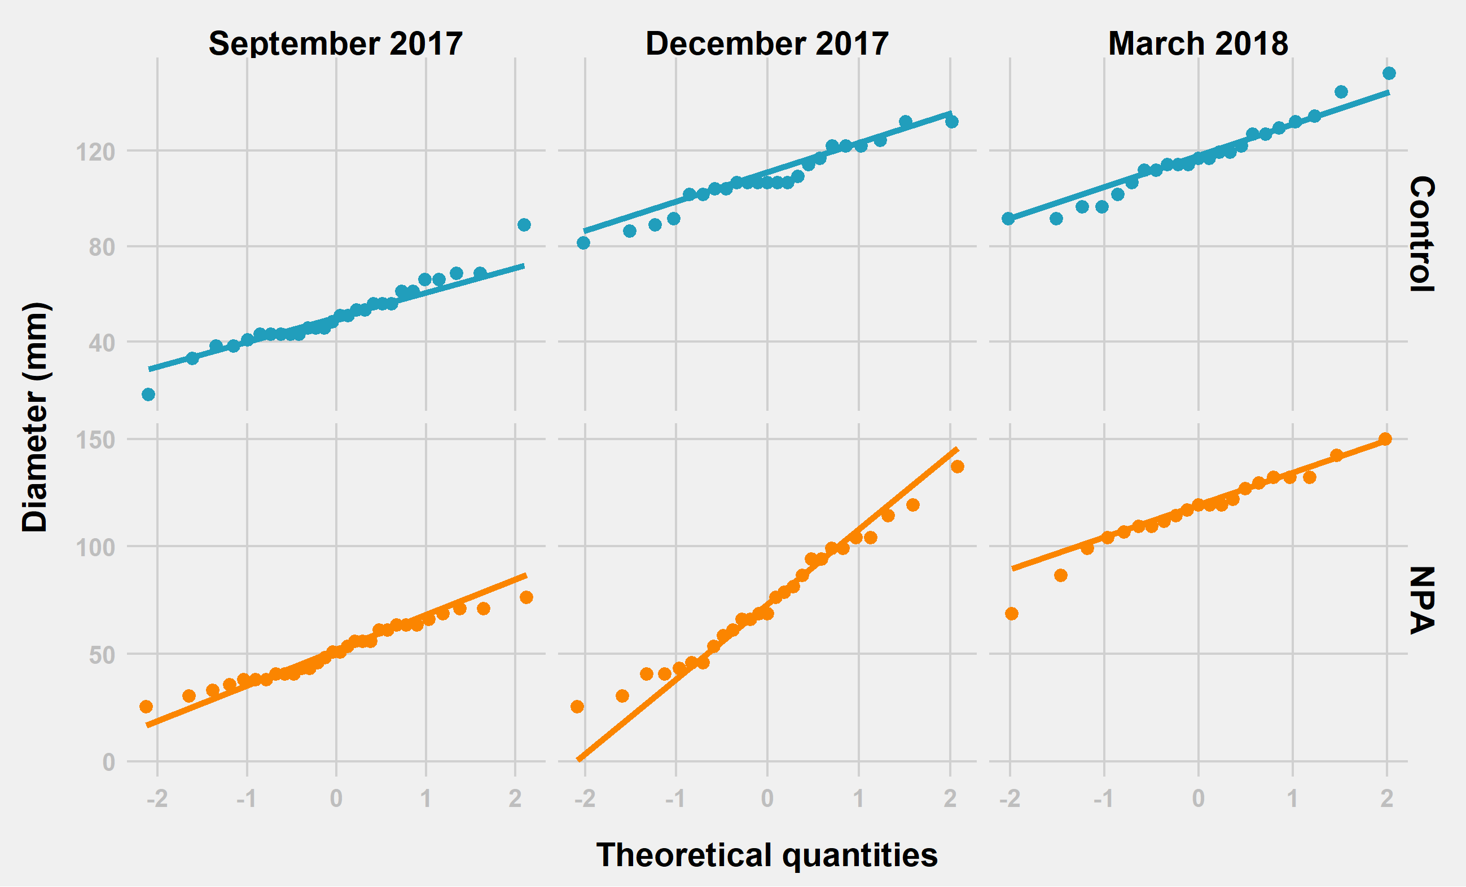

Table () Shapiro Test

|  |  |  |  |  |  |
| --- | --- | --- | --- | --- | --- |
| **Treatment Level** | **Date** | **Variable** | **Statistic** | **P-value** | **N** |
| Control | September 2017 | Diameter (mm) | 0.958 | 0.317 | 28 |
| Control | December 2017 | Diameter (mm) | 0.954 | 0.352 | 23 |
| Control | March 2018 | Diameter (mm) | 0.970 | 0.689 | 23 |
| NPA | September 2017 | Diameter (mm) | 0.968 | 0.505 | 30 |
| NPA | December 2017 | Diameter (mm) | 0.976 | 0.770 | 27 |
| NPA | March 2018 | Diameter (mm) | 0.960 | 0.515 | 21 |

Appendix 2. Diameter difference (mm) – Treatment Level

Figure(). QQ-plot

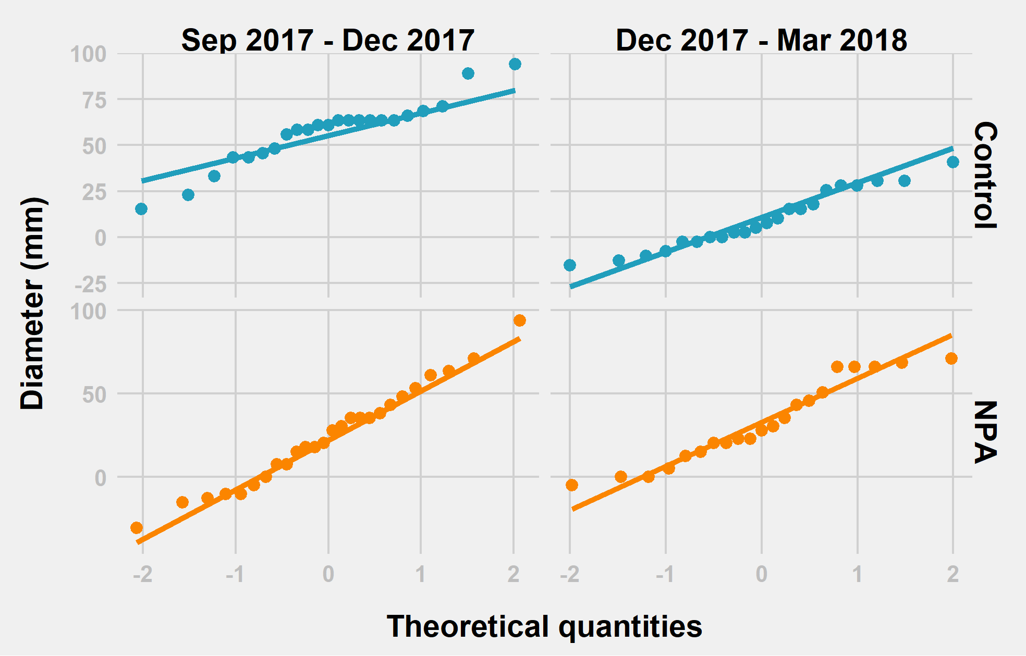

Table () Shapiro Test

|  |  |  |  |  |  |
| --- | --- | --- | --- | --- | --- |
| **Treatment Level** | **Date** | **Variable** | **Statistic** | **P-value** | **N** |
| Control | Sep 2017 – Dec 2017 | Diameter difference (mm) | 0.929 | 0.105 | 23 |
| Control | Dec 2017 – Mar 2018 | Diameter difference (mm) | 0.957 | 0.425 | 23 |
| NPA | Sep 2017 – Dec 2017 | Diameter difference (mm) | 0.984 | 0.944 | 27 |
| NPA | Dec 2017 – Mar 2018 | Diameter difference (mm) | 0.929 | 0.129 | 21 |

Appendix 3. Lateral Shoots – Treatment Level

Figure(). QQ-plot

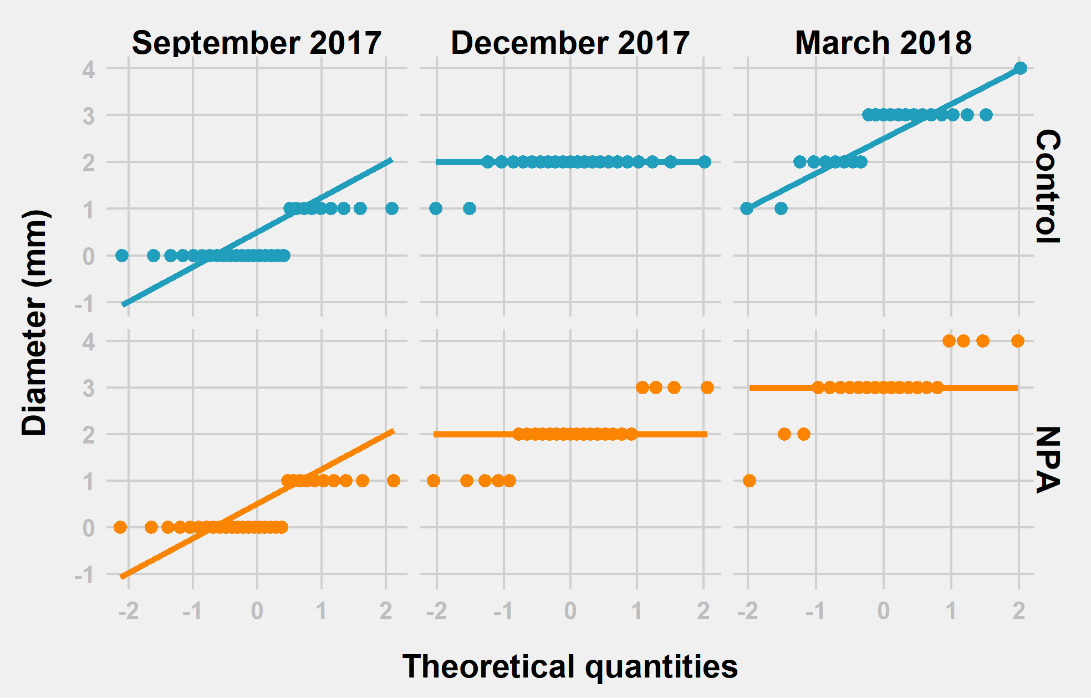

Table () Shapiro Test

|  |  |  |  |  |  |
| --- | --- | --- | --- | --- | --- |
| **Treatment Level** | **Date** | **Variable** | **Statistic** | **P-value** | **N** |
| Control | September 2017 | Lateral Shoots | 0.590 | 0.000 | 28 |
| Control | December 2017 | Lateral Shoots | 0.324 | 0.000 | 23 |
| Control | March 2018 | Lateral Shoots | 0.808 | 0.000 | 23 |
| NPA | September 2017 | Lateral Shoots | 0.59 | 0.000 | 30 |
| NPA | December 2017 | Lateral Shoots | 0.770 | 0.000 | 27 |
| NPA | March 2018 | Lateral Shoots | 0.762 | 0.000 | 21 |

Appendix 4. Inflorescence – Treatment Level

Figure(). QQ-plot

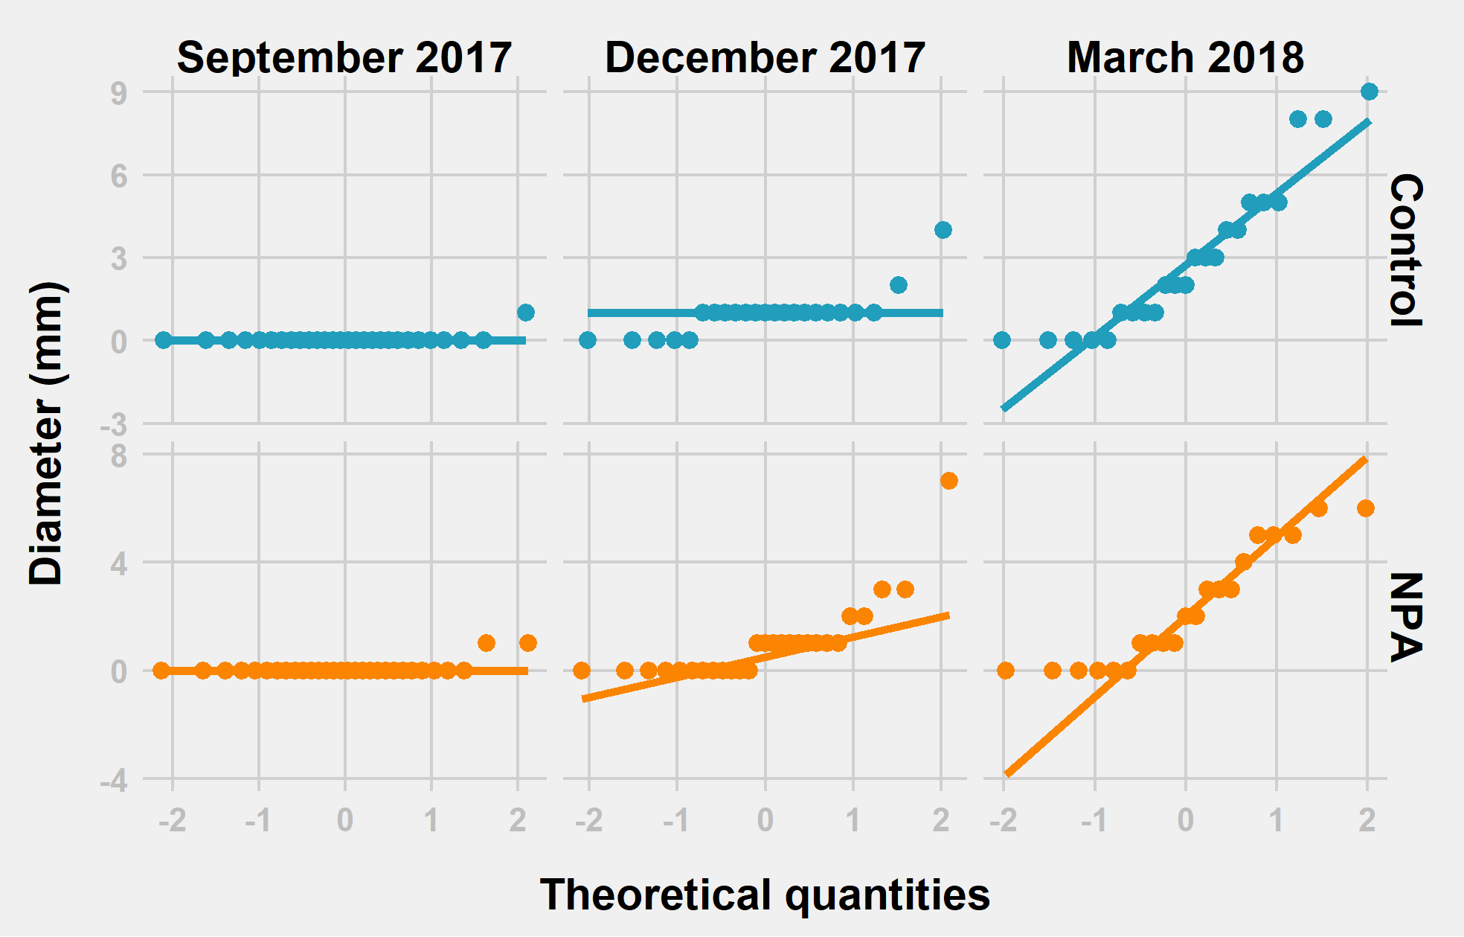

Table () Shapiro Test

|  |  |  |  |  |  |
| --- | --- | --- | --- | --- | --- |
| **Treatment Level** | **Date** | **Variable** | **Statistic** | **P-value** | **N** |
| Control | September 2017 | Inflorescence | 0.188 | 0.000 | 28 |
| Control | December 2017 | Inflorescence | 0.639 | 0.000 | 23 |
| Control | March 2018 | Inflorescence | 0.885 | 0.013 | 23 |
| NPA | September 2017 | Inflorescence | 0.275 | 0.000 | 30 |
| NPA | December 2017 | Inflorescence | 0.655 | 0.000 | 27 |
| NPA | March 2018 | Inflorescence | 0.872 | 0.010 | 21 |